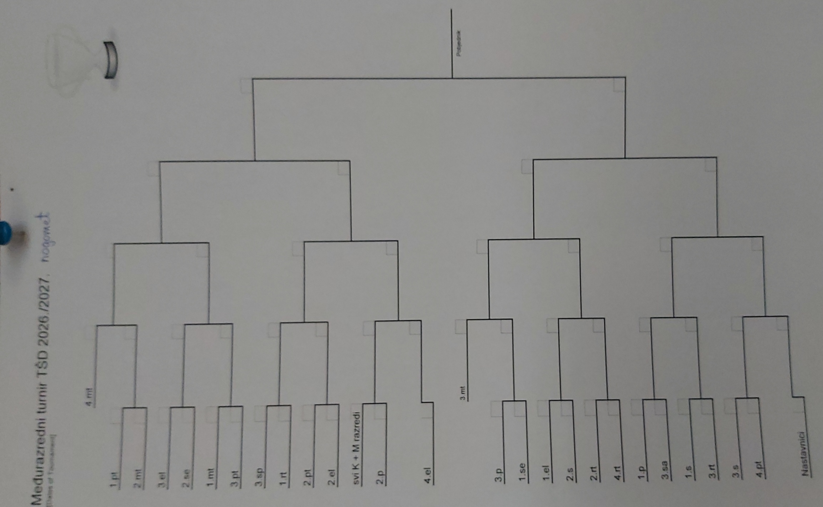
31
30
29
28
27
26
25
24
23
22
21
20
19
18
17
16
15
14
13
12
11
10
9
8
7
6
5
4
3
2
1
<!--(1)---------------------------------------------------------->
<div class="col-title">1st</div>

<div id="myBtn" onclick="sendId(1)">
<div class="team bb pd">
<%= fround[0].fTeam %> <span class="rez br"><%= fround[0].fTeamScore %></span>
</div>
<div class="team br">
<span class="b"><%= fround[0].sTeam %></span> <span class="rez g b"><%= fround[0].sTeamScore %></span>
</div>
</div >

<!--(2)----------------------------------------------------------->
<div class="separator-11"></div>
<div id="myBtn" onclick="sendId(2)">
<div class="team bb br">
<%= fround[1].fTeam %> <span class="rez"><%= fround[1].fTeamScore %></span>
<!--2.MT <span class="rez">0</span>-->
</div>
<div class="team">
<!-- <span class="today le">12:20 va</span> -->
<span class="b"><%= fround[1].sTeam %></span> <span class="rez g b"><%= fround[1].sTeamScore %></span>
</div>
</div>

<!--(3)----------------------------------------------------------->
<div class="separator-1"></div>
<div id="myBtn" onclick="sendId(3)">
<div class="team bb">
<%= fround[2].fTeam %> <span class="rez br"><%= fround[2].fTeamScore %></span>
</div>
<div class="team br">
<!-- <span class="today le">11:30 dv</span> -->
<span class="b"><%= fround[2].sTeam %></span> <span class="rez g b"><%= fround[2].sTeamScore %></span>
</div>
</div>

<!--(4)---------------------------------------------------------->
<div class="separator-11"></div>
<div id="myBtn" onclick="sendId(4)">
<div class="team bb br">
<!-- <span class="b">1.MT</span> <span class="rez g b">0</span> -->
<%= fround[3].fTeam %> <span class="rez br"><%= fround[3].fTeamScore %></span>
</div>
<div class="team">
<!-- <span class="today le">11:05 dv</span> -->
<!-- 3.MT <span class="rez br">0</span> -->
<span class="b"><%= fround[3].sTeam %></span> <span class="rez br g"><%= fround[3].sTeamScore %></span>
</div>
</div>

<div class="separator-1"></div>

